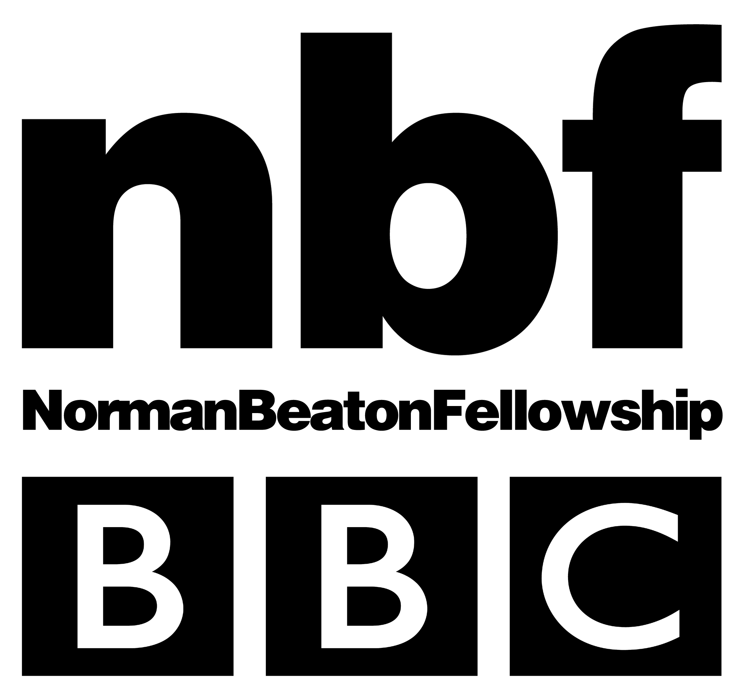

“…Please prepare two contrasting monologues lasting no more than three minutes in total. You don’t need to memorise your pieces, but you should have worked at them sufficiently to know the texts well and be able to anticipate every word. Try to find something that suits your natural voice, and only offer accents if you are totally confident with them. We prefer you not to perform material you’ve written yourself, and you should avoid using song or poetry.”

What do we really want?

It seems obvious to say it, but what we are looking for is great acting talent. We want to see you be different characters, to move us and to entertain us, and we really want you to be brilliant. I’ve been running workshops for the Norman Beaton Fellowship over the past seven years and have often been disappointed by seeing people who I thought had great potential, but for one reason or another did not show themselves at their best – either through lack of preparation or bad choice of material.

Choosing material

Finding good pieces that suit you is obviously very important. The advice to read the play may seem unnecessary if you are only going to be doing a minute’s worth of it, but it is crucially important in the job of persuading us that you ‘are’ that character. You need to have done a lot of preparation to be able to distil the essence of that character into one 90 second excerpt. What things are really important to the character? What are they trying to achieve in their speech? What are their aims during the play? Do they like the person they are talking to? What kind of state are they in? Tired? Elated? Preoccupied? Drunk? At the end of their tether? Not bothered?

Avoid pieces that give no opportunity of change. If the whole piece is delivered in exactly the same way it does not show us very much. Study the piece to see where the character’s moments of change might be. If they start the piece with doubt in their mind is there a turning point when they are suddenly convinced that they are right? Does their attitude to the person they are talking to change at any point? Is there something that amuses them? You do not need to impose arbitrary changes of attitude just for the sake of it, but close study of a well written piece will show the places where the changes can happen.

One of the key words is ‘contrasting’. Three minutes is not long, but it is long enough to really surprise us. When we hear your two pieces, we want to feel that we are hearing two different people. Think about contrasts of pace, of energy, of style, of status or of accents if you are secure with them. For example, if you are doing one slow, serious piece try and find a faster, comic piece for your other one: a very intense character and someone who does not take life too seriously; someone who is arrogantly sure of themselves and someone very shy. We love to hear a variety of accent and it is, of course, a great way of giving contrast. If you have to concentrate too hard on getting the accent right at the expense of the characterisation it is probably best to steer clear of it, but if you are confident then they will immediately give a piece a different feel. But do not think that a different accent alone will be enough to make the piece contrasting. Show us two very different people.

Some people assume that you have to do a Shakespeare or a ‘classical’ piece, even though we do not specifically ask for one. This is certainly not the case. By all means show us if you have a classical piece that you are really confident with, but it has to be as clear and as dramatically successful as any other piece – how clearly can we see the character? What is their state of mind? Where are the changes? Who are they talking to? Shakespearean text, with its challenges of language and meaning is a harder test than a lot of modern pieces. Of course, a brilliantly delivered Shakespeare piece will impress, but do be honest with yourself as to whether it is the best way to show us what you can do. Do not just choose a Shakespeare piece because you think we would expect one. ../..

Who are you talking to?

This is something we often come across in workshops. The piece is well chosen, well prepared and delivered, but it is obvious that the actor is not actually speaking to anybody. It is one of the hardest things to do, particularly in an audition piece – the natural instinct is to concentrate on the character’s words and motivations and easy to forget that you have to create the image of the person you are talking to for the listeners. Make a point of going through the piece purely from the point of view of the person to whom it is being delivered. What attitude would they have to it? When would they try to interrupt? Would they find any of it amusing or offensive? Why don’t they say anything? How easy are they to persuade? Having these things in mind will help to develop your reactions – where you need extra energy, where you can be gentle, where you cannot afford to drop the pace and where you have to. Of course, if you were doing this in a production with another actor these things would be developed in rehearsal, so it is really important to take the time to think about it if you are rehearsing a solo piece.

Learning or not..?

You may choose to do a piece from a play you have performed on stage and have learned. The great advantage of this is that you are very familiar with the character and where the piece fits in the play. But if there is any fear about forgetting your lines please have the text with you. The last thing we are going to worry about in a radio audition is your ability to learn lines. Even if you have done the piece many times on stage there are many things which could throw you – the new and different surroundings, the fact that two people are sat at a table in the same room watching you or the fact that you’ve been told to think about playing to the microphone rather than to a theatre. Any way of relieving the pressure of the audition will help. It is very helpful to have a copy of the text with you as the people on the panel may wish to refer to it if they want to direct you to try something different on a second take.

Readings

In your audition you may be asked to read a short piece from a novel. This may include dialogue from different characters, but will be as if you were recording a reading for radio or an audiobook. In style it is closer to story-telling than a solo piece from a play where you are creating an individual character. Of course the voices in the dialogue will be characterised, but the surrounding narration is usually done in a more neutral style. The narrator may be one of the characters in the book, or may be the voice of the author, but even if they are one of the characters the narration will be different in tone to the dialogue. The best readings make you forget that it is just one actor delivering the dialogue – sometimes not even with wildly varying accents, but just by subtle and swift changes of tone, style and energy. If, in your workshop you are asked to do a reading, you will be given time to prepare it. It is a slightly different skill from doing a part in a play so it is worth practising reading out loud from a variety of short stories or novels and recording yourself at home. Listen to a few readings – you will find them every day on Radio 4, or if you search for ‘Readings’ on the BBC i-player you will find lots.

Listen !

Record your pieces and listen back to them with a critical ear. Play them to someone whose opinion you trust and see whether they work for them.

From our point of view this seems pretty obvious, but it is surprising the number of people who come to radio auditions without ever having listened to radio drama. There are now so many ways of listening again you have no excuse not to listen to a few radio plays to give yourself an idea about the medium. Listen with a critical ear – what works? which characters do you believe in? can you ‘see’ the scene in your head? The most important skills needed to be a good radio actor are exactly the same as in any other dramatic medium, but there are things that will put you at an advantage. Hearing good work will give you a better idea how to achieve good work.

